***FEW INTERVIEW QUESTIONS FOR SELENIUM WEBDRIVER WITH JAVA***

*-What class should be extended to use Serialization?*  
*-What is list and set?*  
*-what is hash table?*  
*-what is iterator?*  
*-Tell me about binary search?*  
*-Tell me about buble sort?*  
*-What is Selenium IDE*  
*-How can we do Iphone and Android app testing in selenium*  
*-What technical issues did you face in selenium*  
*-What is Selenium RC and WebDriver. What is the difference in them (2)*  
*-How many ways can can start the selenium server (1)*  
*-How will you convert integer to String and String to integer in Java (1)*  
*-What do you mean by Object oriented programming. How is it used in selenium? (1)*  
*-how do you download and install selenium? (1)*  
*-Where do you write selenium code if you implement in java (1)*  
*-What all languages are supported by selenium (1)*  
*-What is Murex testing? Do we use Selenium to test Murex? (3)*  
*-How to Integrate Jenkins Hudson integration with selenium for running the scripts in schdule time? (6)*  
*-How to compare Text (not Html strings ) (2)*  
*-How to open csv file (1)*  
*-How to run webdriver scripts with different browsers*  
*-How to do web service testing using selenium webdriver.*  
*-How to identify webElement on web Page*  
*-How to draw an annotation(s) on map using selenium webdriver?*  
*-how to handle list(selecting more than one item) in Rc and Webdriver*  
*-how to handle filedownload in ie and chrome*  
*-How to handle silver light objects*  
*-How to handles Popups!*  
 *-Interview Ques: How to extract data from webtable or weblist, store it in a file and sort the file*  
 *-Is there Assert.assertNotEquals() in webdriver ?*  
 *-Can we schedule the execution of test cases*  
*-Do you any automation tool for desktop application testing?*  
*-How to verify if the webElement is present or not on the webpage..??*  
*-what are reflection api and how are they used in selenium ?*  
*-How to schedule selenium suite using RC and WebDriver*  
*-How to create a new file using Java*  
*-How do you run your automated tests on Mutliple browsers*  
*-How to handle certification error*  
*-How would you deal with Ajax issues?*  
*-What is most difficult challenge you have faced in automating a web application*  
*-How to execute selenium webdriver tests after completion and deployment of build thru Jenkins?*  
*-Give two examples of functionality that cannot be properly tested with automated testing software?*  
*--List the advantage/disadvantages: Selenium WebDriver Vs QTP*  
*-What is inheritance in Java? How is it applied in Selenium?*  
*-What are the drawbacks of Webdriver?*  
*-Give me 5 points about what is the use of Framework (jUnit or TestNg)*  
*-What is the difference between verify and Assert?*  
*-How to run the test script in selenium on specific time?*  
*-What to do at very first if you want to start a Selenium automation tool in your project?*  
*-How do we keep expected result in the Seleniumj automation script?*  
*-What is the use of Class HtmlUnitDriver and when we have to use the Class HtmlUnitDriver*  
*-can we handle windows popup using selenium?*  
*-There are 3 fields like House Number, Mobile Number and email address. How will you validate fields*  
 *-What is the difference between client-server application and web application?*  
*-How can you test application in multiple browsers in selenium when making the framework*  
*-How will you run 1000 test cases and generate reports*  
*-What are user extensions*  
*-What is difference between QTP and selenium*  
*-What is the architecture of selenium WebDriver*

# TestNG – Test Automation with Selenium

*by*SEETARAM*on JANUARY 15, 2012*

TestNG framework can be used for automation testing with Selenium (web application automation testing tool). Then, definitely a question will popup in our mind “why this framework is needed?” Is it possible to execute Selenium tests without frameworks like JUnit or TestNG. Answer is “Yes”, it is possible to execute Selenium tests without using these frameworks. But, is it possible to get proper reports without framework? How the verification points or checkpoints are going to be handled? How the exception handling is done? If we do not have any frameworks, then it is difficult to get proper reports, handle checkpoints, or exception handling.

Either we should use any of the frameworks available like JUnit, TestNG or we should design our own framework.

In one of the previous post, I have explained [how to setup TestNG with Eclipse IDE](http://selftechy.com/2012/01/09/setting-up-testng-with-eclipse).  It is better go through that post before doing anything explained in this post.

Let us have a look at the code snippet below:

package com.selftechy.testng;

import com.thoughtworks.selenium.*;

import org.testng.annotations.*;

public class TestNGDemo extends SeleneseTestBase{

public Selenium selenium;

@BeforeMethod

public void setUp()throws Exception{

selenium = new DefaultSelenium("localhost",4444,"*chrome","http://selftechy.com");

selenium.start();

selenium.windowMaximize();

}

@Test

public void testNGDemo() throws Exception {

selenium.open("/");

selenium.click("link=TestNG (Next Generation Testing Framework) – Understanding Annotations");

Thread.sleep(10000);

verifyTrue(selenium.isTextPresent("Annotation:"));

selenium.click("link=Selenium");

Thread.sleep(10000);

selenium.click("css=a[title=\"Introduction to Selenium\"]");

Thread.sleep(10000);

}

@Test

public void testTestAbout() throws Exception {

selenium.open("/");

selenium.click("link=About");

selenium.waitForPageToLoad("30000");

verifyTrue(selenium.isTextPresent("Selenium, QTP, Java"));

selenium.click("link=Home");

selenium.waitForPageToLoad("30000");

selenium.click("link=TestNG – Next Generation Testing Framework");

selenium.waitForPageToLoad("30000");

verifyTrue(selenium.isTextPresent("Need for a Testing Framework:"));

}

@AfterMethod

public void tearDown(){

selenium.stop();

}

}

The Java class “TestNGDemo” is implemented in Eclipse IDE using TestNG framework.

In the above code, there are two test methods, which are marked with @Test annotation. There are two other methods, “setUp” and “tearDown” which are marked with @BeforeMethod and @AfterMethod annotations. Hence Before executing each test, setUp method will be executed. After the execution of each test, tearDown gets executed. Hence, Selenium gets instantiated and browser gets opened and closed twice during the execution.

How to execute the test?

Click Run –> Run As –> TestNG Test

[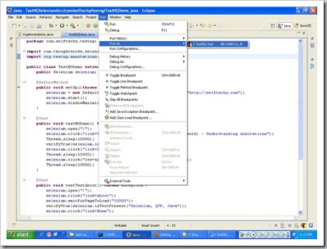](http://selftechy.com/wp-content/uploads/2012/01/TestNGRunAs1.jpg)

**Output of the execution should be as below:**

[TestNG] Running:

C:\Documents and Settings\parwathi\Local Settings\Temp\testng-eclipse-1339593504\testng-customsuite.xml

PASSED: testNGDemo

PASSED: testTestAbout

===============================================

Default test

Tests run: 2, Failures: 0, Skips: 0

===============================================

===============================================

Default suite

Total tests run: 2, Failures: 0, Skips: 0

===============================================

[TestNG] Time taken by org.testng.reporters.EmailableReporter@1a679b7: 15 ms

[TestNG] Time taken by org.testng.reporters.SuiteHTMLReporter@1e51060: 16 ms

[TestNG] Time taken by org.testng.reporters.JUnitReportReporter@337d0f: 0 ms

[TestNG] Time taken by org.testng.reporters.XMLReporter@e102dc: 0 ms

[TestNG] Time taken by [TestListenerAdapter] Passed:0 Failed:0 Skipped:0]: 0 ms

Test execution also creates set of XML & HTML reports. TestNG creates “test-output” folder in the root folder, inside which we can see the reports.  Below are the screenshots of some of the reports created by TestNG.

[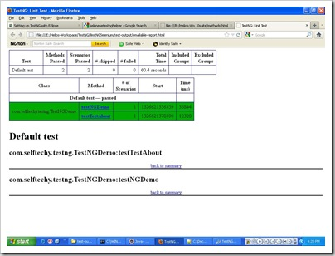](http://selftechy.com/wp-content/uploads/2012/01/emailablereport.jpg)

[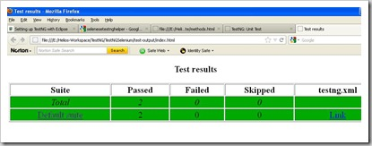](http://selftechy.com/wp-content/uploads/2012/01/index.jpg)

[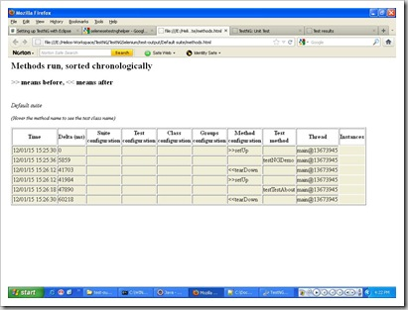](http://selftechy.com/wp-content/uploads/2012/01/methods.jpg)

**What we have learnt so far?**

1. Need for TestNG framework
2. How to create a Selenium test with TestNG
3. Annotations used in the test
4. How to execute the Selenium tests with TestNG
5. What are reports generated and how they look
6. What is the output of the execution

what is the diff b/w Ant and TestNG. Both will be useful to display reports only? or Is there any specific difference. Please update

ant is a build tool… testng is a test framework…

# Introduction of TestNG framework - Advantages of TestNG over Junit framework

In **Selenium WebDriver training tutorial** we have seen how to run Selenium scripts using JUnit framework. Until now we have execute selenium tests but we have not generated reports in JUnit. In this Selenium training article series we are introducing powerful new testing framework called TestNG. The TestNG framework means Next Generation testing framework, so we are seeing what all next generation features available in TestNG, also I will talk about advantages of TestNG over Junit. I will be discussing about different ways of using TestNG features in my coming articles.

I do not say that don’t use JUnit, but you should really consider using TestNG for your next project. Apparently TestNG is more complete and clean than JUnit.

# What is TestNG?

TestNG is testing framework inspired from most popular JUnit framework used for the Java programming language. The TestNG framework is introduced to overcome the limitations of JUnit framework. Most of the automation users are using this framework because of its advantages & more supported features. Until we have executed selenium test script but not even generated test reports. So using this TestNG framework we will learn how to generate test reports.

[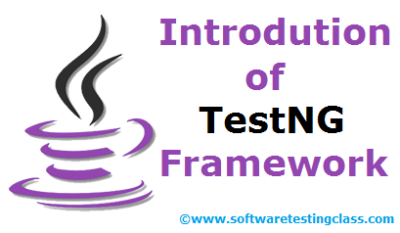](http://www.softwaretestingclass.com/wp-content/uploads/2013/09/selenium-testng-framework.png)

# Features of TestNG Framework:

TestNG supports many powerful features & it is easy to use. Let’s see what all new features are supported in new testing framework:

* Support for parameters.
* Supports dependent methods testing.
* Test configuration flexible.
* Supports powerful execution model.
* Embeds BeanShell for further flexibility.
* TestNG has a more elegant way of handling parameterized tests with the data-provider concept.
* For the same test class TestNG support for multiple instances.
* Extendibility of using different Tools and plug-ins like Eclipse, Maven, IDEA etc.
* Default JDK functions for runtime and logging (no dependencies).
* Supported different Annotations like @BeforeSuite, @AfterSuite, @BeforeClass, @AfterClass, @BeforeTest, @AfterTest, @BeforeGroups, @AfterGroups, @BeforeMethod, @AfterMethod, @DataProvider, @Factory, @Listeners, @Parameters, @Test.

TestNG supports annotations which are very helpful to guide test case executions. Similarly in JUnit, the TestNG annotations are always preceded by the ‘@’ symbol. It permit you do parallel execution of test cases & we can also skip the test cases effortlessly while executing test cases.

TestNG is specially designed to cover all types testing categories like Unit, Functional testing, Integration testing, End-to-end etc. Using TestNG framework allows us to generate test reports in both HTML and XML formats. Using ANT with TestNG, we can generate primitive Testng reports as well.

# Advantages of TestNG over Junit:

1. In TestNG Annotations are easy to understand over JUnit.
2. In TestNG there is no constraint like you have to declare @BeforeClass and @AfterClass, which is present in JUnit.
3. As method name constraint is present in JUnit, such method name constraint is not present in TestNG and you can specify any test method names.
4. In TestNG enable you to grouping of test cases easily which is not possible in JUnit.
5. TestNG supports following three 3 additional setUp/tearDown level:  
   @Before/AfterSuite, @Before/AfterTest and @Before/AfterGroup.
6. TestNG do not require extend any class.
7. TestNG allows us to define the dependent test cases each test case is independent to other test case.
8. TestNG allows us to execute of test cases based on group. Let’s take a scenario where we have created two set of groups “Regression” & “Sanity”. If we want to execute the test cases under Sanity group then it is possible in TestNG framework.
9. Parallel execution of Selenium test cases is possible in TestNG.

**Conclusion:**  
If you enjoy reading this article please make sure to share it with your friends. Please leave your questions/tips/suggestions in the comment section below and I’ll try to answer as many as I can.

In Next article, we will see “Steps to install TestNG in Eclipse”.  
You can also Subscribe by E-mail and get All New articles delivered directly to your Inbox.